Name: _________________________________ Date:_____________
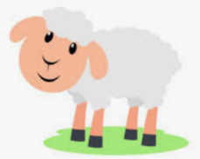
Parable of The Lost Sheep
Reflection: What does this parable tell us about God?
______________________________________________________________________________________________________________________________________________________________________________________________________________________________________

